Combining computer vision and standardised protocols for improved measurement of live sea urchins for research and industry
Bas C. De Vos, Mark D. Cyrus, Brett M. Macey, Theodore Batik, John J. Bolton
First published: 13 November 2023 https://doi.org/10.1002/aff2.137
SECTIONS
PDF
TOOLS SHARE
Abstract
To allow sea urchin aquaculture to achieve its intended scale, efficient and precise methods for measuring large numbers of urchins in commercial-scale operations are needed. Current protocols for measuring urchin test (shell) dimensions and mass are time-consuming and prone to high measurement error, thus inconvenient in research and impractical in a commercial context. This study investigates and compares various measurement methods with a newly developed computer vision approach developed in this study, to establish a single protocol using precise, efficient and accessible methodology for measuring live urchins. We show that urchin wet mass can vary up to 8.73% depending on time out of water; this is significantly reduced to an average of 0.1% change by allowing urchins to drip-dry for at least 90 s prior to weighing. We found the conventional vernier calliper method used to measure urchin dimensions to be both time-consuming and imprecise (mean coefficient of variation (CV) of 2.41% for Tripneustes gratilla). Conversely, the computer vision programme we developed measures with higher precision (mean CV of 1.55% for T. gratilla) and is considerably faster. The software uses a series of hue saturation value filters, edge detection algorithms and distortions to measure the diameter of the test (excluding spines) of multiple urchins at once. The software is open-source, and the protocol does not require specialised equipment (can be performed with a mobile phone camera). When the computer vision application is combined with the simple procedures described in this paper, to reduce measurement inaccuracies, urchin wet mass and diameter can be more efficiently and precisely determined. For a larger scale context, this software could easily be incorporated into various tools, such as a grading machine, to completely automate various farm processes. As such, this study has potential to assist urchin data collection in both research and commercial contexts.

1 INTRODUCTION
Sea urchin gonads are in high demand as valued culinary delicacies. This has led to the over-exploitation of many wild stocks and the understanding that urchins have great potential in aquaculture (Brown & Eddy, 2015). However, global sea urchin aquaculture (echinoculture) has not achieved considerable scale as its net global production only contributes approximately 0.01% of the global wild harvest (James, Evensen, et al., 2017). As is the case with all products, to successfully produce and develop cultivation methods for large quantities of sea urchins, precise and efficient measurement methods are essential (Føre et al., 2018; Grosjean et al., 1998; James et al., 2017b). Currently, methods most frequently used to measure live sea urchins involve weighing animals individually and then measuring the test diameter and height with callipers. These methods are not only imprecise, as shown by this study, but also highly time-consuming and impractical on a commercial farm scale, where conceivably millions of urchins will have to be measured monthly for grading and re-stocking purposes. The latter constraints are further exacerbated for fast-growing urchin species. Therefore, if urchins are to be cultured at commercial scale, more precise and efficient methods of measurement need to be developed.
Precise measurements of urchin mass and outer test dimensions are also fundamental in a research context that extends beyond aquaculture. The significant ecological, social and economic importance of these echinoderms has spurred extensive research with approximately 64,300 scientific publications referring to them in the past 20 years. For data among studies to be comparable, and to increase the precision and accuracy of data within studies, data collection protocols must be standardised and optimised. Standardised measurement methods for fish have long been established (Ricker & Merriman, 1945; Schreck et al., 1990), and more recently, techniques have been developed for sea cucumbers (Watanabe et al., 2012). For sea urchins specifically, standardised protocols have been developed for the collection, handling and analysis of urchin coelomocytes, that is the immune effector cells of sea urchins (Smith et al., 2019). There are, however, currently no clear standardised scientific methods widely accepted for measuring the dimensions or mass of live urchins.
Precise and reliable measurements are fundamental in any data analysis, whether they are intended for scientific publication or used to make management decisions on an aquaculture farm. There are various factors influencing wet mass measurements of sea urchins, which are not directly related to their true biomass. However, these factors cannot be completely removed; the total measurement error can be minimised by reducing and standardising their impact. Wet mass is defined as the mass of the whole organism and can be measured when the organism is alive. This definition does not include surface water. An urchin emersed from a body of water and immediately weighed will have considerably more surface water compared to an urchin left to drip-dry for a set period. Although it is impractical and detrimental to the organism to have all its surface water removed, the more standardised the quantity of surface water on each urchin, the more precise the measurement will be. Certain papers mention specific units of time they allow urchins to drip-dry before being weighed (Ellers & Johnson, 2009; Russell, 1998; Santos et al., 2020; Selden et al., 2009), but these papers do not all use the same units of time, and many other papers do not mention how long the urchins had been emersed before being weighed. Furthermore, the urchin mass measurements are likely influenced by the release of fluid when emersed. Strongylocentrotus purpuratus is known to emit an ‘emersion fluid’, which has been shown to be over a third of the urchin's volume and has a significant influence on its wet mass (Burnett et al., 2002). We have noted similar observations for Tripneustes gratilla and Parechinus angulosus. This response appears to be correlated to the orientation of the urchin, where the rate of emersion fluid released is considerably greater when the urchin is upside down. The release of emersion fluid and the rate thereof will influence the wet mass measurements of urchins, and its influence should thus be standardised as far as is possible. Feed residing in the digestive tract may also skew the mass of an urchins, which is why some studies recommend starving animals for a few days prior to weighing (Cyrus, 2013; Sonnenholzner-Varas et al., 2019). Contrary to this, one could theorise that the density of most urchin feed is similar to that of water and, as the volume of an urchin is fixed, the fullness of the stomach will not affect mass. In support of this idea, a study comparing the wet weight of a group of Paracentrotus lividus–fed Ulva lactuca daily with urchins starved for 36 days found no significant difference in wet weight between treatments (Arafa et al., 2006). An objective of this study is to provide a methodology for accurate wet weight measurements of urchins, and recommendations for reducing the impact(s) of these factors. Therefore, we investigate three factors that may add unnecessary measurement error, namely surface water, emersion fluid and feed.
Determining sea urchin test diameter is also important and requires methodological development, both for research and industry. Some studies have shown that certain treatments have no significant influence on mass but do significantly affect urchin test diameter (Cyrus et al., 2015). Conversely, Cárcamo (2015) showed the opposite, which emphasises the benefits of measuring both the size and mass of urchins. Urchin mass can be used to estimate diameter, and similarly, diameter can be used to estimate mass, with species- and possibly condition-specific equations derived from regression models (Balisco, 2015; Kawamata, 1997; Stuart, 1981; Suskiewicz & Johnson, 2017). The creation of these models do, however, require large, accurate and specific data sets of the diameter and mass measurements and make the assumption of dependence among these values, which may result in missing findings as shown in Cyrus et al. (2015) and Cárcamo (2015). Estimating mass from diameter, or vice versa, will further reduce the accuracy of data due to some natural variation between the mass and diameter relationship in urchin populations. Therefore, although the mass and diameter can be correlated, it has not been done for all urchin species may result in missing findings and is likely to reduce data quality. As such, we suggest both the mass and size be measured.
In the literature, sea urchin size is generally quantified by measuring diameter and sometimes height using vernier callipers (Balisco, 2015; Cárcamo, 2015; Cyrus et al., 2014; Shpigel & Erez, 2020). This measurement technique may not be precise because urchins are not circular but pentagonal. This means the recorded value of the ‘diameter’ of an urchin will vary depending on which part of the pentagon is measured by the callipers. Furthermore, measuring a sea urchin test with callipers requires the blades of the callipers to be against the test, which means they must pass through the layer of spines. Because urchins actively attempt to protect their test with their spines, this is not only difficult and time-consuming but also frequently results in spine breakage and loss. Spine loss influences resource allocation as urchins regenerate broken spines, thus resulting in reduced somatic and/or reproductive growth (Ebert, 1968; Edwards & Ebert, 1991; Haag et al., 2016). Furthermore, the handling of urchins increases stress and reduces behavioural and innate immune defence responses, which can lead to increased susceptibility to disease (Bose et al., 2019). As such, the handling of urchins should be minimised. Other methods of determining urchin dimensions have been applied. Measuring urchin test surface area via 3D laser scanners has been reported to have high accuracy but requires the animals to be sacrificed (Shpigel & Erez, 2020). Urchin tests have been measured via photographs (Mos et al., 2016), where the user manually selects the measuring points on an image. Although this may be accurate, it is labour-intensive and thus not appropriate for use on a commercial scale.
As the echinoculture industry develops and larger quantities of urchins need to be routinely measured and quantified, more practical, rapid and efficient methods of measurement will need to be developed. This paper will explore methods for large-scale sea urchin measurements, such as total basket mass and computer vision. Computer vision technology extracts useful information from images or videos. Machine vision uses computer vision to trigger an action, such as automating a task (Davies, 2012). Both have been applied to and greatly optimised for measurement of specific organisms of aquaculture or fisheries interest, including fish size, condition and behaviour studies in aquaculture (Saberioon et al., 2017), and for determining volume and mass of oysters (Damar et al., 2007), scallops (AiGuang et al., 2006) and sea cucumbers (Liu et al., 2015). Sea cucumber machine vision is now even being applied to ‘sea cucumber catching robots’ (Ge et al., 2018). Currently, we are not aware of any computer vision applications involving sea urchins. However, it has been identified as a possible tool for the valuation of spine colour to predict gonad quality and quantity (Mos & Dworjanyn, 2019). Computer vision can involve costly optical sensors, specific imaging requirements and complex coding. It can also be highly accessible. This technology can be conducted via mobile phone cameras and make use of robust, simple and open-source software, which does not require expertise in programming. The more practical and accessible the application, the more likely it will be used.
The objective of this study is to compare various standard measurement techniques with a newly developed computer vision approach and establish guidelines on the most precise, efficient and accessible methodology to measure live urchins. Through repeated measuring and measurement comparisons, this study provides expected standard deviations (SD) for the various measurement techniques. Although scientific data collection rules that measurements should be taken by a single operator, it is not always feasible for a single person to conduct this task when large quantities of urchins need to be quantified in a short time frame. Thus, we include measurement error values for multiple operators. The SD values we provide here can be used by anyone to conduct power analyses to assist experimental design for live sea urchin studies. This could further improve sea urchin research methods in any field or context.

2 METHODS
This study primarily used the subtropical/tropical urchin T. gratilla, which has been identified as highly suited for aquaculture (Cyrus et al., 2014, 2015; Juinio-Meñez & Hapitan, 1998). The T. gratilla used in this study was produced from larvae and reared at the Department of Forestry, Fisheries and the Environment (DFFE) Marine Research Aquarium (MRA) in Cape Town, South Africa. The temperate Cape urchin, P. angulosus, was used to further verify the applicability of the computer vision programme. These animals were collected from the seashore in front of the same research facility. The urchins used in this trial were held in baskets (made of 2 mm oyster mesh) with dividers, which created six compartments per basket. Each compartment held an individual urchin. Compartments were labelled to ensure the correct urchin was quantified each time. These baskets were placed in tanks with water parameters suitable to the specific urchin species. This study was approved by the DFFE Aquaculture Animal Ethics Committee (AAEC) without prejudice.

2.1 Factors influencing wet mass
Nine urchins (T. gratilla) of various size classes (14.92–218.63 g) were removed from the water. After 5 s, a tared weighing boat was placed beneath the urchin, and weight was recorded to the nearest 0.01 g. Urchins were then removed from the weight boat. The water in the weigh boat was removed using a paper towel, and the weigh boat was re-tared. After 30 s of being removed from the water, the urchins were returned to the weigh boat and remeasured as before. This process was repeated at 60, 90, 120, 180, 300, 480 and 600 s for each urchin.
To determine if recent feeding influences the wet mass of urchins, a group of T. gratilla (n = 36; 14–219 g) were not fed for a week. These urchins were then removed from the water for at least 90 s, which was found to be optimal in reducing the variance of wet weight, before placing on a clean, dry weigh boat and weighing to the nearest 0.01 g. Following this, urchins were supplied with a known mass of aquaculture-grown Ulva lacinulata, equivalent to 4% of their body mass. After 24 h, when most urchins had consumed all the feed, the urchins were weighed as described above.
The precision of measuring the total mass of a group of urchins in a basket was compared to the average mass of the urchins quantified separately with five repetitions (described in detail in Section 2.2). Each basket, containing six individually housed urchins, was weighed once in the morning, midday and afternoon (to account for possible diurnal change in mass) after being removed from the water for a minimum of 90 s. Once the baskets were emptied of urchins, they were re-weighed after being removed from the water for at least 90 s to determine basket weight.

2.2 Assessing precision of manual diameter, height and mass measurements
The same group of 36 urchins (described above) were measured in terms of wet mass, height and diameter 5 times (i.e. 5 measurement sets). Measurements were performed by three people/operators. Operator 1 conducted three of the measurement sets, whereas operators 2 and 3 conducted one measurement set each. Operators 1 and 2 were experienced in measuring urchins, but it was the first time that operator 3 had worked with urchins. Everyone received the following basic instructions on measuring the urchins: (1) The blades of the vernier callipers must be placed against the test of the urchins and not the spines; (2) the callipers must be placed as centrally as possible on the urchin and the value recorded to the nearest millimetre; (3) the wet weight must be measured to the nearest 0.01 g; (4) the scale must be zeroed among urchins, and the urchins must be removed from the water for at least 90 s before being weighed. The sets of measurements occurred hourly, and the time taken to conduct the measurements was recorded.

2.3 Computer vision

2.3.1 Hardware
To ensure accessibility of the computer vision programme, no specialised equipment was used. All images were taken in a simple, homemade ‘photo box’ using mobile phone cameras. The programme does not necessarily need standardised lighting or distance between the camera lens and the specimen being measured. If the photo box designed for this study is replicated, it will increase the likelihood that the default light and distortion settings described below will appropriately capture contours, meaning the urchin's measurements will be accurate without needing to alter the settings of the program. The ‘photo box’ was constructed from three Styrofoam boxes (700 × 350 × 180 mm3) frequently used to transport seafood, which were stacked on top of each other. The bottom ‘floors’ of the top two boxes were removed. To allow for the image to be taken, a small hole was cut in the centre of the lid of the top box. Urchins were placed at the bottom of the lowest box. It was necessary to have approximately 10 mm gaps between urchins. A solid, black reference object with a known diameter was placed on the outermost left-hand side of the box, with no other objects placed further left of this object. Once the reference object and urchins were placed in the bottom of the container, the lid was firmly closed, before a mobile phone was placed on the lid with the camera directly above the central hole. The camera was set to a magnification of 1× without any photographic filters selected. More specific instructions on the camera set-up can be found in Appendix A. To check for instrument bias, repeated images of the urchins were taken with two different mobile phones, a Samsung A52 and Huawei P30. To compare time efficiency among measurement methods (manual vs. digital), the time taken to conduct this process was recorded, including the time taken to process images once appropriate parameters had been found.

2.3.2 Software
This programme (Supporting Information section; de Vos & Batik, 2022) was written in Python 3 (Van Rossum & Drake, 2009), primarily using the OpenCV library (Bradski, 2000). The complexity of applying computer vision to urchins involves distorting the image in a manner where only the test is measured and not the spines. A series of filters and constraints on the contour area were applied to achieve this. Initially, a hue saturation value filter was shown to remove most spines (Figure 1a), predominantly via the reduction of lightness. The image was then turned to greyscale, and Canny contour detection algorithm (Canny, 1986) was applied to obtain an edge map (Figure 1b). Following this, a series of basic morphological operations (i.e. blur, erode and dilate) were applied to remove the last of the spines and smooth the image (Figure 1c). Once the distorted image represented the urchin test with sufficient precision (Figure 1d), the contours were determined using topological structural analysis by border following techniques (Suzuki & be, 1985).
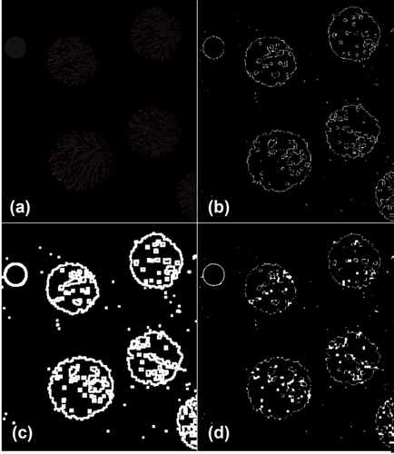
FIGURE 1
Open in figure viewerPowerPoint
(a–d) A portion of an image of Tripneustes gratilla with the filters applied using default settings of the computer vision programme to measure the diameter of the test not including the spines. Part (a) is the initial hue saturation value (HSV) colour filter, mostly reducing the lightness. The following part (b) converted the previous image into greyscale and applied dilution filters and canny edge detection. Part (c) applied erosion filters over (b). Part (d) is the results of contours determined using topological structural analysis by border following techniques post-colour and morphological images.
A minimum area bounding rectangle was then set around the complete contour of all objects identified in the image (Figure 2). To quantify the size of each object, a pixel-per-metric ratio was determined through the calibration of the reference object of known location and dimensions. The reference object was positioned as the left-most object of the image, and its length (vertical diameter) was a required input. The programme divided the number of pixels of the length by the known width of the reference object. This set a pixels-per-metric ratio, which was then applied to all lengths and widths of the bounding boxes around the objects in the image. As most mobile phones lack a truly flat lens, the shape of objects was distorted slightly, where objects on the left or right extremes of the image have an apparent greater horizontal width than in reality. Objects on the bottom and top extremes have the opposite distortion. After extensive optimisation, it was found that this distortion effect could be most effectively reduced by choosing the smallest value between the vertical or horizontal width of an object as the primary measurement value.
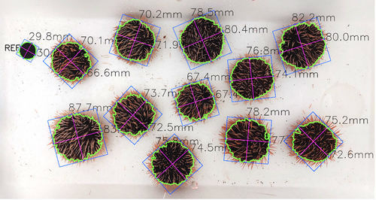
FIGURE 2
Open in figure viewerPowerPoint
Results of a full Tripneustes gratilla image once run through the programme. Green lines demonstrate the edge detection, blue rectangles represent minimum area bounding and pink lines represent the widths. Note the reference object in the top left corner.

2.3.3 Assessing precision of computer vision–determined diameter
T. gratilla (n = 20) were each randomly labelled with the numbers 1–30 written on a small sheet of plastic that was attached to the urchin with an elastic band. These urchins ranged in size from 55.33 to 79.67 mm, as these were the sizes available at the time. The urchins were placed randomly into the photo box, and their image was taken as described above. The urchins were removed from the box and then immediately returned in different positions to the previous, and their image was retaken. This was repeated three times, providing three measurements for each labelled urchin, thus determining the CV. This exact experiment was repeated for 20 P. angulosus, which ranged in size from 15.17 to 58.17 mm. To provide an intraspecific comparison, the diameter of these 20 P. angulosus urchins was also measured using callipers, 3 times per individual, by the same operator.

2.4 Statistics
For all analyses, the statistical computing environment R (R Development Core Team, 2017) was used. Excel was used to organise and present some data. The assumptions of independence and non-selectivity were met as discussed in the experimental designs. Significance was assigned to p values of <0.05.

2.4.1 Factors influencing wet mass
To reduce the influence of urchin size, the mass of the first measurements (after 5 s of being removed from the water) was divided from all the measurements from each urchin and multiplied by 100 to transform data into a percentage of initial weight. No extreme outliers were observed as no data points exceeded the interquartile range by 1.5 times. Normality was found for each group by Shapiro–Wilk tests (p < 0.026). The assumption of data sphericity was met (Mauchly's test = 0.34). One-way repeated-measures analysis of variance (ANOVA) was used to detect a significant effect of time on urchin wet mass, and a Bonferroni pairwise t-test was applied to detect significant differences among time intervals. A logarithmic function was fitted to this data to determine the possible presence of a near-constant mass (asymptote).
The paired mass data between the pre-fed and fed urchins were shown not to be normally distributed by a Shapiro–Wilk test (p = 0.013); thus, an exact Wilcoxon signed-rank test was applied.
To determine the similarity between weighing the wet mass of urchins individually and urchins together in a basket, a paired t-test was applied. The data were normally distributed (p = 0.360).

2.4.2 Comparing urchin measurement methods
There is no ‘gold standard’ urchin measurement method that can be used to directly comparing alternative methods. Thus, to allow for simple comparative analysis, this investigation applied a statistical approach similar to that of Watanabe et al. (2012), where CV was used as the primary quantitative tool. The CV is determined by dividing the SD of the repeated measurements by their mean. Unlike SD, this provides a measure of dispersion of measurements, which is standardised, thus allowing fair comparison between multiple data sets and metrics (Hervé, 2010). A one-way ANOVA and Tukey post hoc test were applied to detect significant differences among treatments. Height measurements from callipers were excluded from statistical analysis as this parameter had considerably higher variability than the other methods and could not meet the assumptions of an ANOVA. Once these treatments were removed, all assumptions were met for normality (Shapiro–Wilk test, p = 0.097) and homogeneity of variances (Levene's test; p = 0.135). To test the accessibility and consistency of the computer vision application, measurements of the same images, but from two different phone cameras, were tested for significant differences via a paired t-test. A paired t-test was also applied to compare the diameter measurements between the callipers and computer vision.

3 RESULTS

3.1 Factors influencing wet mass
There was a decrease in mass between the first measurement, taken at 5 s, and all the following measurements (Figure 3). The greatest differences observed were between the 5 s and the 10 min weighing, with an average decrease in mass of 6.49% and the greatest difference of 8.73%. A one-way repeated measures ANOVA revealed that time out of the water had a significant effect on mass (F (8,40) = 97.327, p < 0.001). There were no significant differences between the 90 and 120, 120 and 180, 300 and 480 and 480 and 600 s intervals (adjusted p > 0.05), with all other time intervals being significantly different (adjusted p < 0.05). The average CV and SD of mass within individuals from the 5 to 600 s intervals were 2.18% and 1.74 g, respectively. Within the 90–120 s intervals, it was 0.01% and 0.29 g, and between 90 and 600 s, it was 0.01% and 0.65 g. A logarithmic function accurately fitted the relationship between time out of the water and average mass of all urchins divided by the initial weight at 5 s (y = −0.013ln(x) + 1.0153, R2 = 0.97; Figure 3). There were no mortalities or any clear indications of stress after this trial. The mass of urchins after being fed was reduced on average by 0.28%, although the difference was not significant (p = 0.093).
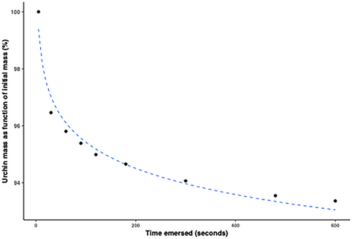
FIGURE 3
Open in figure viewerPowerPoint
A logarithmic function representing the percentage reduction of mass averaged between nine urchins weighed at various times following removal from a body of water (y = −0.013ln(x) + 1.0153, R2 = 0.97). The percentage value was determined by dividing the mass of each urchin at individual time points by its initial mass, 5 s.

3.2 Measurement method comparison
The variability of height measured with callipers was considerably larger than the other methods (Figure 4), where the CV was 3.98% when measured by the single operator and 6.46% when measured by multiple operators. There was a significant effect on CV when measuring test diameter with callipers, manually weighing urchins or determining diameter using computer vision tools (F(4,187) = 22.73, p < 0.001). Although the CV of diameter with callipers from a single operator (mean, 2.02%) was smaller than that of multiple operators (mean, 2.41%; Figure 4), a Tukey post hoc test revealed no significant difference (p = 0.23). Similarly, there was no significant difference in CV for mass measurements between single and multiple operators (p = 0.81). Urchin mass determined by a single operator had the lowest mean CV (0.84%), which was significantly lower (p = 0.002) than the CV of the computer vision measurements (mean, 1.55%). Computer vision did not produce measurements significantly more variable than the measurements of urchin mass determined by weighing from multiple operators (mean 1.05%; p = 0.073). Similarly, the computer vision CV did not differ significantly from the measurements of the diameter using callipers by a single operator (mean 0.84%, p = 0.066). The entire process of manually measuring the diameter, height and wet mass of 36 individual urchins took on average 42 min, which is approximately 70 s per urchin. The computer vision and total mass method of 25 urchins took on average 9 min, which translates to 21.6 s per urchin.
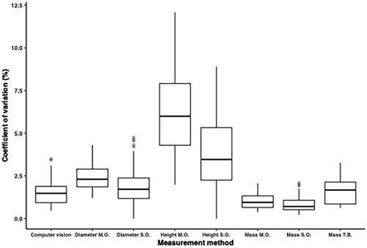
FIGURE 4
Open in figure viewerPowerPoint
Boxplot comparing the distribution of coefficient of variation between various measurement methods for Tripneustes gratilla. Treatments with matching letters did not have significantly different coefficients of variation from one another; there are no letters for height as it was not included in the statistical analysis. M.O. is an abbreviation for multiple operators, S.O. is a single operator and T.B. is for total basket mass, where all the urchins were measured together in their basket.
For P. angulosus, the CV for computer vision measurements, using the default image processing settings, was 2.21% and lower than that of the manual measurements by a single operator with a CV of 2.65%, and there was no significant difference (F(1,39) = 0.791, p = 0.379).
The images captured by the Samsung phone on average measured the diameter to be 0.18% greater than the Huawei; however, a paired t-test found no significant difference in measurements between phones (t(29) = 0.451, p = 0.655).
The average CV of total basket method for determining urchin mass (with empty basket mass deducted) was 1.67%, and when compared to the sum of individual urchin mass in the basket, the total basket mass was 3.26% larger and significantly different (p = 0.014).

4 DISCUSSION
The findings of this study are used to recommend a protocol, which uses both modern computer vision and basic instructions to significantly increase precision and decrease the time and effort required to quantify the average mass and test dimension of multiple urchin species. This protocol should not only reduce handling stress and spine loss of urchins, thus preventing reduction of growth, but also enhance the statistical power (likelihood of not detecting a significant difference even though there is one, otherwise known as a Type II error) of urchin experiments. This could make the difference among meaningful results or vague deductions, as true significant differences can be overlooked. Conducting an experiment on urchins where there are four replicates (baskets/groups of urchins), the minimal detectable difference between treatments is 2.5 mm in diameter and the significance level is 0.05 is used as an example. If one uses the calliper method with multiple operators, there will be a 56.83% chance of detecting a significant difference. With the computer vision method, for the same experiment, there would be an 88.3% chance of detecting a significant difference. This example demonstrates the importance of reducing measurement error, especially for time- and resource-intensive experiments. SDs of various measurement methods are provided (Table B1) and could be used to conduct power analyses during experimental design.
TABLE B1. The coefficient of variation (CV) and standard deviation (SD) of various measurement techniques for two different urchin species and for a single operator (S.O.) and multiple operators (M.O.).
Species | Method | CV (%) | SD
Tripneustes gratilla | Computer vision | 1.55 | 1.03 mm
 | Mass S.O. | 0.84 | 0.62 g
 | Mass M.O. | 1.05 | 0.85 g
 | Diameter S.O. | 2.02 | 1.11 mm
 | Diameter M.O. | 2.41 | 1.59 mm
 | Height S.O. | 3.76 | 1.36 mm
 | Height M.O. | 6.24 | 2.42 mm
 | Total basket mass | 1.67 | 6.60 mm
Parechinus angulosus | Diameter S.O. | 2.66 | 0.87 mm
 | Computer vision | 2.06 | 0.83 mm
- Note: The SD could be applied in power analyses for other studies but cannot be used as a comparison of variance between measurement methods.
To achieve maximum precision of wet mass measurements, urchins should be removed from the water body/holding tank(s) and allowed to drip-dry for between 90 and 120 s before measuring weight. However, we suggest weighing urchins anytime between 90 s and 10 min after removal. This is because it may not be practical to measure urchins in this 30 s window and after 90 s most drip-loss had occurred. Water loss thereafter was negligible. If a similar hypothetical experiment as previously described is conducted where the dependent variable is mass and the minimal detectable difference between treatments is 2.5 g, then waiting for at least 90 s gives a power value of 99.71%. However, measuring mass at any time from 5 s until 10 min after removal from the water would provide a statistical power of only 50.13%.
This study found no significant difference between mass before and after feeding, suggesting it is not necessary to purge animals (via starvation) to ensure mass is not influenced. On the other hand, it may be beneficial to allow for a short purging period prior to handling and/or transport to reduce metabolism, as is done in fish aquaculture (Lines & Spence, 2012). This study observed an apparent slight decrease in mass post-feeding and the reason for this is unclear. It may be related to possible differences in density between Ulva and coelomic fluid. Coelomic fluid could be displaced externally as the urchin fills its digestive tract with feed (Ulva). Although the biological and chemical properties of urchin coelomic fluid have been studied extensively, it appears no research was been conducted on its volume and how its volume changes. This could be worth further investigation.
Although not significant, variation among calliper measurements in diameter and for mass measurements was lower for a single operator than for multiple operators. Although it is not always possible for a single person to quantify a vast number of urchins, it should be practised when possible and it is considered a basic protocol in scientific data collection to avoid operator bias. The total basket mass method for determining the combined weight of urchins in a basket did differ significantly from the combined mass of the individually weighed urchins. Therefore, we suggest removing urchins from their basket, but they can be weighed together as a group. It will be necessary to remove the urchins from their basket anyway to take an image for computer vision.
This study found the computer vision programme, using default and generalist image processing settings, to be more precise and efficient when compared to measuring urchin diameter manually with callipers, as multiple urchins can be measured at once. Computer vision was at least three times faster than the manual method. Although measurement rates could vary for several reasons, the computer vision protocol we developed in this study will be exponentially more time-efficient than the reported 21.6 s by increasing the number of urchins in each image. The exact number of urchins the software could process is dependent on the image quality and processing power of the computer used. The manual method requires an operator and a scribe, whereas the provided computer vision protocol only requires a single person, halving labour requirements.
Urchin diameter measured by computer vision was shown to be significantly larger than diameter measurements using callipers. This is due to further limitations of the calliper method and not limitations of the computer vision programme. As with all echinoderms, urchins are not round but rather pentagonal. Most spines occur on the vertices (corners) of the pentagon (Figure 5a). When measuring with callipers, the operator will generally avoid the spines and will measure from the edges (flats). As such, the calliper measurement will frequently not run through the centre on the urchins and therefore have a relatively lower value to the computer vision value. The pentagonal shape of urchins is one of the primary reasons the computer vision programme used the minimum bounding area technique to create a rectangular shape on the extremities of an object and then determine the diameter of this rectangle (Figure 5b). In geometry, the diameter of a pentagon is the diameter of a circle drawn on the vertices of a pentagon (Pritchard, 2003). This means the ‘true diameter’ of an urchin will be greater than the value given via calliper and computer vision measurements (Figure 5c); however, the computer vision value should be closer to this true value. For the scope of this study and for the sake of measuring urchins, this is not too relevant and will not be an issue given the same measurement methods are compared. To clarify, direct measurements of outer test dimensions from computer vision and the calliper cannot be compared absolutely; however, functions such as certain growth rates could be compared.
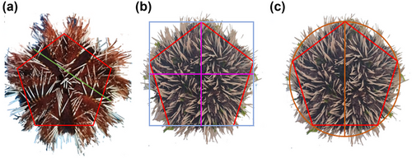
FIGURE 5
Open in figure viewerPowerPoint
(a–c) Various urchin ’diameters’ are shown over the pentagonal shape of urchins (indicated by the overlayed red pentagon). The green line in part (a) demonstrates the measurement frequently made with callipers to avoid breaking spines. Note how this line does not cross the centre of the urchin. Part (b) shows the diameter outputted from the computer vision programme is the length and width (pink lines) of the minimum area building box (blue square). Part (c) depicts the diameter as defined in geometry, where the length of the vertical brown line would be the diameter. Different images of urchins were used to clearly demonstrate the shape (b and c) and then to show the distribution of spines (a).
The CV of manual diameter measurements of T. gratilla was lower than P. angulosus. This is likely the result of P. angulosus being more challenging to measure accurately due to their harder, denser and longer spines, which increases the difficulty of getting the blades of the callipers against the test. This suggests that although the SDs provided in this study can be useful, they should be used with some caution when conducting power analyses for different urchin species. The higher precision of the computer vision programme with T. gratilla than P. angulosus was the result of colour variation among P. angulosus individuals (colours include black, orange, red, purple and white), which made it difficult to fit into generalist parameters of the colour filter. Regardless of this limitation, computer vision was still more precise than manual measurements of P. angulosus and now the default parameters, which were also used for analysis in this study, should work for urchins of most colours. There is still much scope for refinement and optimisation of the script for specific species. There was decreased precision due to mobile phones not having a truly flat lens. This could be improved by using more appropriate cameras, although this would reduce accessibility. Currently, this software is suitable for batch operations (single image of urchins); however, it could be easily extended for live/continuous operations. This would allow for various machine vision applications such as a conveyer belt grading machine, which could completely automate the highly labour-intensive grading process.
In conclusion, using total group mass to determine average individual mass after 90 s of drip-drying and then applying the computer vision programme to determine diameter will provide precise measurements, with less disturbance to the urchins in considerably less time than previously used procedures. Manually measuring diameter with callipers is only a suitable method for quantifying small numbers of urchins. There is great potential to further develop the computer vision programme. It can be further refined to improve the precision of measurements of different urchin species. This protocol and new methods should assist anyone who needs to quantify a large group of urchins, regardless of their access to equipment and resources or whether the context is aquaculture-, ecology- or fishery-related.

AUTHOR CONTRIBUTIONS
Bas C. De Vos: Conceptualisation; data curation; formal analysis; funding acquisition; investigation; methodology; project administration; software; validation; visualisation; writing – original draft. Mark D. Cyrus: Conceptualisation; supervision; writing – review and editing. Brett M. Macey: Funding acquisition; project administration; supervision; writing – review and editing. Theodore Batik: Software. John J. Bolton: Funding acquisition; project administration; supervision; writing – review and editing.

ACKNOWLEDGEMENTS
This study was financially supported by the Skye Foundation (S236) and the International Joint Laboratory LIMAQUA with funding from the French National Research Institute for Sustainable Development (IRD) and the NRF/CNRS/IRD/CIRAD Collaboration Program Fund (CNRS22081651133). Additionally, this study also received funding from the EU Horizon 2020 Research & Innovation Programme ASTRAL Project under Grant Agreement No. 863034. Thanks to Marissa Brink-Hull, Vuyokazi Kutu, Trygve Heide and Mckayla Erasmus for their assistance with data collection. A special thanks to Inga Hitzeroth, Penelope Haw and Claudia Hitzeroth for their proofreading, advice and encouragement. We would also like to thank the DFFE Aquaculture Research Facility in Sea Point, Cape Town for providing the facilities to conduct this research.

APPENDIX A:
Protocol: Determining mass and diameter of live urchins
Set-up
- All urchins from each experimental unit can be weighed together. An appropriate weight scale (ideally with at least two decimal places but depending on the quantity of urchins per treatment) and container must be acquired. The container must be stable on the scale and easy to tare. This could be the photo box described below.
- Any container could be used for the photo box provided it serves the following functions:
- Appropriate size to hold the required number of urchins, with adequate spacing between them (±15 mm).
- Somewhat standardises lighting conditions.
- Standardises the distance from the camera to the urchins.
A plain white background is strongly recommended. If a photo box is constructed as used in this study and described below, it will increase the likelihood that the default settings of the computer vision programme will be appropriate and fewer alternations will be required.
3. To replicate our photo box, attain three ‘fish’ Styrofoam boxes (700 × 350 × 180 mm3) and stack them on top of each other, retaining only the lid of the top box. Remove the bottom ‘floors’ of the top two boxes, making a continuous box from the top lid of the upper box to the floor of the bottom box. To allow for the image to be taken, a small hole must be cut in the centre of the lid of the top box. A reference object, with a known diameter and ideally completely black, must be placed on the most left-hand side of the image, and no other objects placed further left of this object.
Acquiring images and mass
Slowly remove the urchin basket from the water while gently shaking the basket to ensure urchins detach from the sidewall, fall into the water and remain on the bottom of the basket. Do not allow urchins to fall to the bottom of the basket once it is completely out of the water as this can damage the urchins.
Remove the basket from the water body and allow it to drip-dry for at least 90 s before weighing.
- Remove urchins from the basket and place them into a container that has been tared and record mass.
Place urchins into the photo box (or leave them in if this was the container also used to determine mass).
- It is necessary to have approximately 15 mm gaps between urchins.
- Ensure the reference object is on the most left-hand side of the image.
Once the reference objects and urchins are placed in the bottom of the container, the lid should be closed, and a mobile phone should be placed on the lid with the camera directly above the central hole.
- The camera should be set to a magnification of 1× without any other filters.
The filename of the image must be changed to the name of the group of urchins. This name will be used to label the urchin measurement in the output CSV file.
- Return urchins to the body of water as soon as possible.
Processing images
- The programme can be found at https://github.com/TheoBatik/urchinvision.
- We found that images with a size of approximately 1.2 Mb were precise while not requiring too much processing time.
- Input diameter of reference object for ‘widths’ in the ‘args’ command (line 34).
- Input image location.
- Run the programme, follow prompts and check if contours follow the test of the urchin.

APPENDIX B:
Table B1

Open Research

REFERENCES
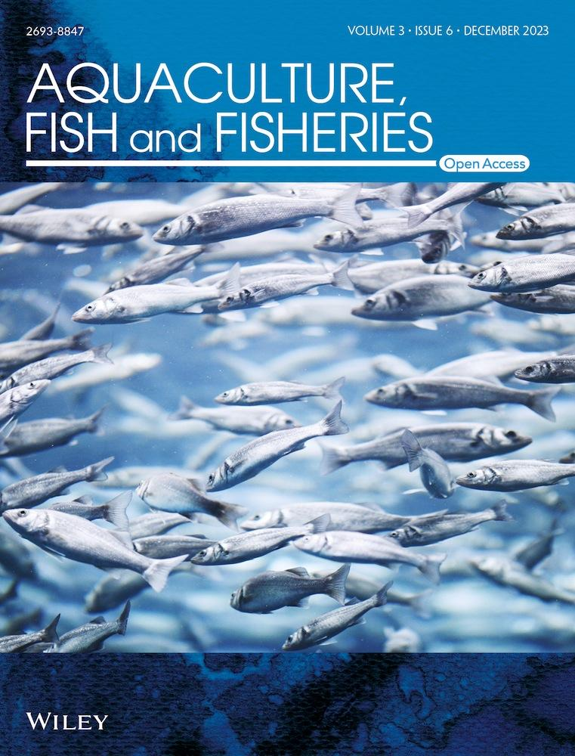
Volume3, Issue6
December 2023
Pages 507-517

Figures

References

Related

Information

Recommended
- Life in the Shallow Sea: From Shells to Urchins
Tropical Island Recovery: Cousine Island, Seychelles, [1]
- Half a century (1954–2009) of dissection data of sea urchins from the North American Pacific coast (Mexico–Canada)
- T. A. Ebert, J. C. Hernández, S. Clemente, M. P. Russell, L. V. Basch, R. A. Boolootian, P. M. Detwiler, M. C. Kenner, A. L. Lawrence, J. M. Lawrence, D. L. Leighton, J. S. Palleiro, J. S. Pearse
- Ecology
- The effects of trophic interactions and spatial competition on algal community composition on Hawaiian coral reefs
- Mark J. A. Vermeij, Meghan L. Dailer, Sheila M. Walsh, Mary K. Donovan, Celia M. Smith
- Marine Ecology
- Evaluation of separation of seed mussels from macroalgae using chlorination
- Bradley M. Skelton, Andrew G. Jeffs
- Aquaculture, Fish and Fisheries
- Stakeholder perspectives on the 2023 Ghana National Aquaculture Development Plan: An integration within the ecosystem approach framework
- Jacob Zornu, Matthew Oyih, Martin Binde, Jennifer Viglo, Hayford Agbekpornu, Mary Nkansa, Saraya Tavornpanich, Kari Norheim, Edgar Brun, Kofitsyo S. Cudjoe
- Aquaculture, Fish and Fisheries

